**Japanese values and philosophy**

Japanese culture was influenced by many different factors. Long period of isolation lasting to XIX century. Influence of other Asian counties, especially Korea and China. American and European influence in a last 50-60 years. But still, Japan has their own unique culture with their own special values and philosophy.  
  
Japanese people main philosophy is mostly about living the moment. As in some other Asian countries Japan society is very strict about education and career. And in such a stressful life full of responsibility and emotionless working it is very important to spend your free time with joy. A lot of Japanese holidays is based on natural phenomena’s,

Cherry Blossoms, for example.   
  
Ikigai is a perfect example of how Japanese people treat their life. Ikigai is “a reason for being” – a perfect state of happiness. This concept is kind of similar to Nirvana. Here’s an image that explains it quite good:

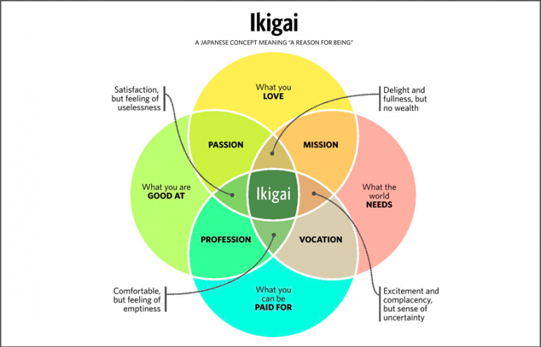

As you can see there is four main things that makes you reach Ikigai, it’s what you **love**, what you’re **good** at, what you’re **paid** for, and what the **world needs**.

Ikigai is actually very hard to reach, and since Japanese society is very competitive there is a lot of people that are not happy. Japan has one of the highest suicidal rates. The most common reason is a job loss. Job loss is a big problem in Japan, because usually companies hire people for a very long period, lots of people work their whole life in one company. Also, if you lost your job it may mean that you would not have a money for your retire.

“Fall seven times and stand up eight.”

-Japanese Proverbs

Japanese people treat nature very carefully. Lots of beautiful natural phenomena’s don’t last for too long. Sakura Blossom is usually last for one week. In that short period Japanese people treat the moment by resting under the tree and drinking sake. Some say that a petal fallen into your cup is a big luck. Such a life philosophy can be seen in many different aspects of Japanese society. Religion is one of the examples. Traditional Japanese religion is Shinto, which is based on kami (“gods”, “spirits”). Everything can be a kami, from sun, rock, animal or ancestor’s spirit. But Japanese people also accept Buddhism. And those two doesn’t conflict with each other, many people just believe in both. For example, when people wed they usually prefer Shinto’s wedding rituals, but for the funeral process Buddhistic traditions is more likely. Christian belief is not so popular in Japan although there are some Christian churches. One of the Japanese prime ministers Ichiro Hatoyama (1954-1956) was Protestant. The unity of different religions and how they live in harmony in one society shows us that Japanese society is indeed wonderful. One more thing that is wonderful about japan is how high technologies and traditions live in piece together. Robots working as a stuff, high speed trains, one of the best economies on one hand, and beautiful traditional structures, handmade traditional cloth, farms that work manually with their hands and simple tools, all of these is one country.  
  
Not to mention how Japanese feel about their job. Lots of companies still hire people for life-long period because for Japanese people job is not only the place where you earn money, but also a place where you live. Japanese often gather to meal with their colleges, spend holidays together, because your job is your place in life, it’s your way to be worth for the world.

“If the labor of a human being is not grafted to the good of society, the life of this person is in vain” *

-Jigoro Kano

Not only general traditions are important for Japanese people, but also family traditions. It is common to have a whole family with many generations of one particular business, it might be acting, cooking or fishing, for example.

Japanese have many of those little things that all together creates a peaceful, respectful and successful society.

“Japan never considers time together as time wasted. Rather, it is time invested.”

-Donald Richie

*I didn’t found this exact quote in English and translated it myself, so it might be not 100% accurate.

As an information source I mostly used [Wikipedia](https://www.wikipedia.org/) and [“Multifaceted Japan Documentary film”](https://www.youtube.com/watch?v=0llOKwYCf6Q&t=1316s&ab_channel=InternationalChodievFoundation) (Russian).